Diffraction Grating Spectroscope

By Riley Oblander

# Purpose

The University of Washington Bothell’s TrickFire Robotics team is participating in the Mars Society’s University Rover Challenge. This competition involves a mission where the team must take and analyze a soil sample for the presence of extant or extinct life. This process must be automated and self contained within the rover itself. The competition rules stipulate a budget limit for the construction of the rover, therefore an off the shelf spectroscope system would be too expensive for this application.

# **Background**

## Diffraction

When light passes by an edge, or through a gap or slot, it bends towards the edge. The magnitude of this effect is dependent on the wavelength of the light involved. When multiple gaps are arranged into a grating with a known number of lines per mm then the angle a given wavelength of light diffracts can be calculated for each order as follows:

$θ=sin^{-1}(\frac{αλ}{d})$

Where $θ$ is the angle of diffraction, $α$ is the order, $λ$ is the wavelength, and $d$ is the distance between gaps in the grating. This effect can be used to perform a Fourier transformation of the light, separating the intensity of the light by frequency across a line in space.

## **CCD Camera**

A CCD sensor is a transducer for transforming the amplitude of the light incident on the detector into electrical voltages. They are sensitive to a wide range of frequencies from IR to UV. The efficiency of CCD’s is high at about 70% of incident light converted, this makes it ideal for detecting low intensity signals.

# Design

## Optical Path

We designed two optical paths for use at different stages of the construction: the first is the experimental setup which is used to test and calibrate the electronics and software, and the second is the optical path for taking measurements of a given sample.

The experimental setup starts with an array of 9 LED’s of different frequencies from 455 nm to 730 nm, that light then passes through a precision machined slot, 100um wide and 12mm tall, this slot ensures that only a small slice of the light passes through the diffraction grating, without creating a diffraction effect that would land onto the detector. If the slot is too wide then it would reduce the practical resolution of the device, if the slot is too small it would create ghost lines offset from the main signal. After the slit, the single vertical line of light enters the diffraction grating with 1000 lines/mm. The grating splits the light into individual frequencies and projects it onto the final component, the linear CCD detector.

The final setup is similar to the experimental setup, but instead of the 9 LED array, we start with a green 532 nm laser, which first passes through a beam splitter. The beam is split into two paths, the first path goes to the sample tube where it excites any dyes or fluorescent material. This fluorescent light then returns back into the beam splitter where it follows the same path as the other green laser beam. The combined laser fluorescent light passes through a low pass filter which cuts off all wavelengths less than 550 nm, thus passing the lower frequency, higher wavelength fluorescent light but attenuating the laser light. After this step everything is the same as the experimental setup, with the machined slot, diffraction grating and CCD detector.

## Mechanical

The most critical mechanical design consideration is the placement of the detector in relation to the output face of the diffraction grating. We design for a range of wavelengths from 400 nm to 800 nm. The length of the sensor we wish to project the spectra onto is 8.25mm.

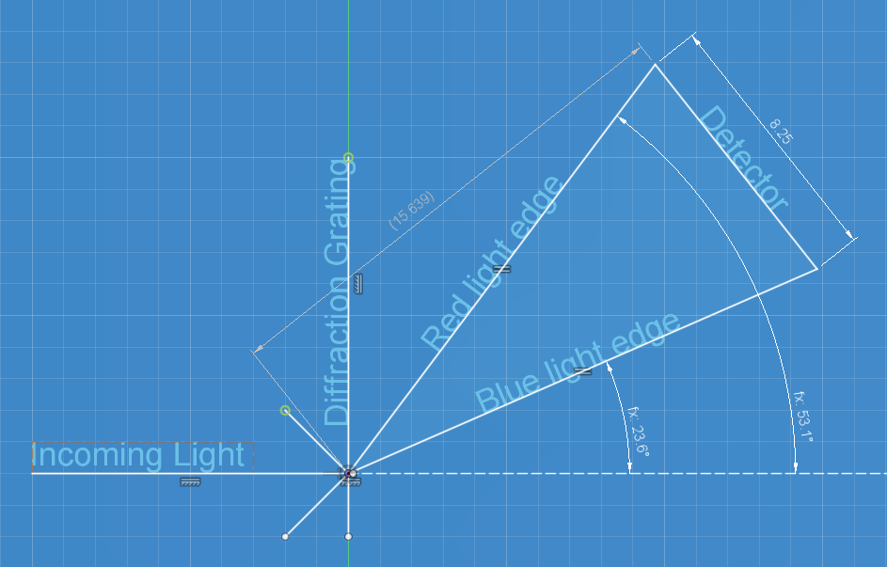

Figure 1. Diagram of detector placement

## Electrical

To detect and digitize the intensity of light over a linear area we utilized a Toshiba TCD1103 1500 pixel linear CCD camera, an AD7495 ADC, and an ESP32-C3 microcontroller.

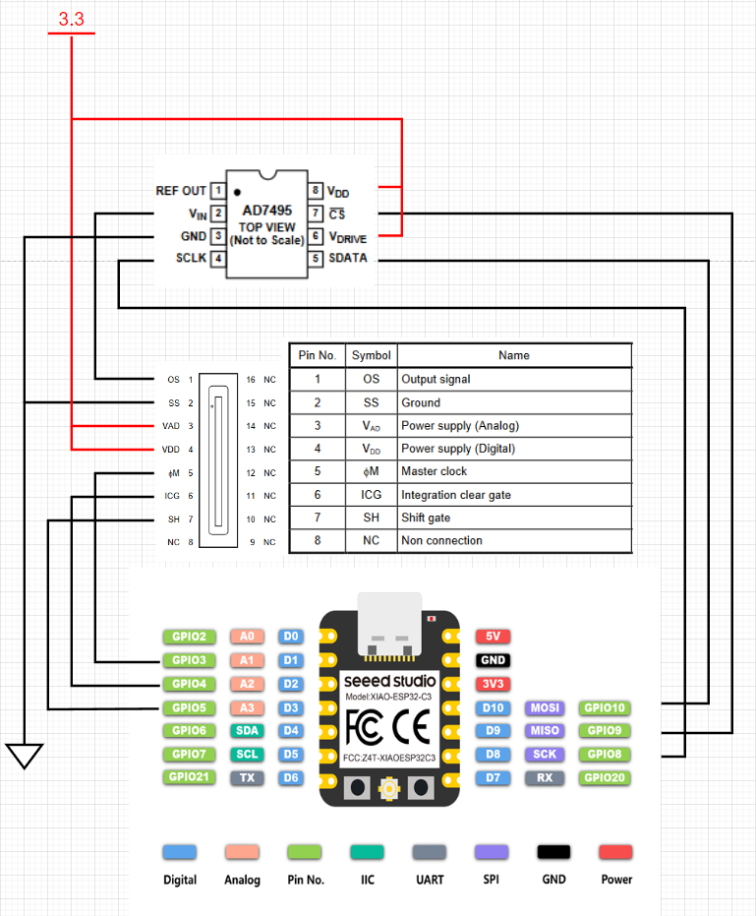

Figure 2. Schematic diagram of detector electrical components

## The TCD1103 can run at a master clock frequency of 400kHz to 4MHz which translates into a pixel rate of 200kHz to 2MHz. Each pixel is generated sequentially as an analog voltage on the OS pin of the detector every two master clock pulses after the initial setup period, therefore the ADC must be capable of a sample rate of 200kHz to 2MHz. The onboard ADC of the ESP-32C3 has a maximum sample rate of 83kHz, so we utilize the AD7495 ADC which has a maximum sample rate of 1MHz and a convenient SPI interface.

## Software

There are two layers of software required for this device: the firmware, written in C using the Arduino IDE, runs on the ESP32-C3 and handles all of the electrical signals on the detector board, the application program, written in python and using the IMGUI framework, runs on a PC connected to the ESP32-C3 over a USB serial connection and displays the resulting spectrum.

To process the signal we created a multi-stage filter pipeline. First a hybrid digital low pass filter that utilizes both an average and median low pass filter to smooth out the noise from the signal, then we pass the signal through a digital high pass filter to level out the signal and remove any slow changes. This creates a bandpass filter that is tuned to only show changes that could be caused by diffraction lines. Due to the non-linear sensitivity of the detector and the inherent non-linear effect of the high pass filter we apply a non-linear scaling function to cancel out these undesirable effects. Finally we perform a normalization step to dynamically adjust a linear amplifier to keep the highest peaks of each frame the same magnitude. As a separate step we can also average multiple frames together to create a much clearer and more reliable result.

# Implementation

## 3D Printing

To manufacture the main body of the device we utilized 3D FDM (Fused Deposition Modeling) 3D printing. We started the design with the distance and angle from the diffraction grating calculations to place the center of our adjustment carriage. We implemented a 2D adjustment mechanism to center the band of frequencies we are interested in on the device while also allowing forward and backward movement to utilize as much of the sensor as possible to maximize the effective resolution. Once the proper location was found we fixed the carriage into position with hot glue so it was unlikely to shift out of position. The body insulates the detector from ambient light, and serves to hold most of the components of the optical path. We also created adapters, light guides, and a housing for the LED array module to allow it to be integrated with the spectroscope.

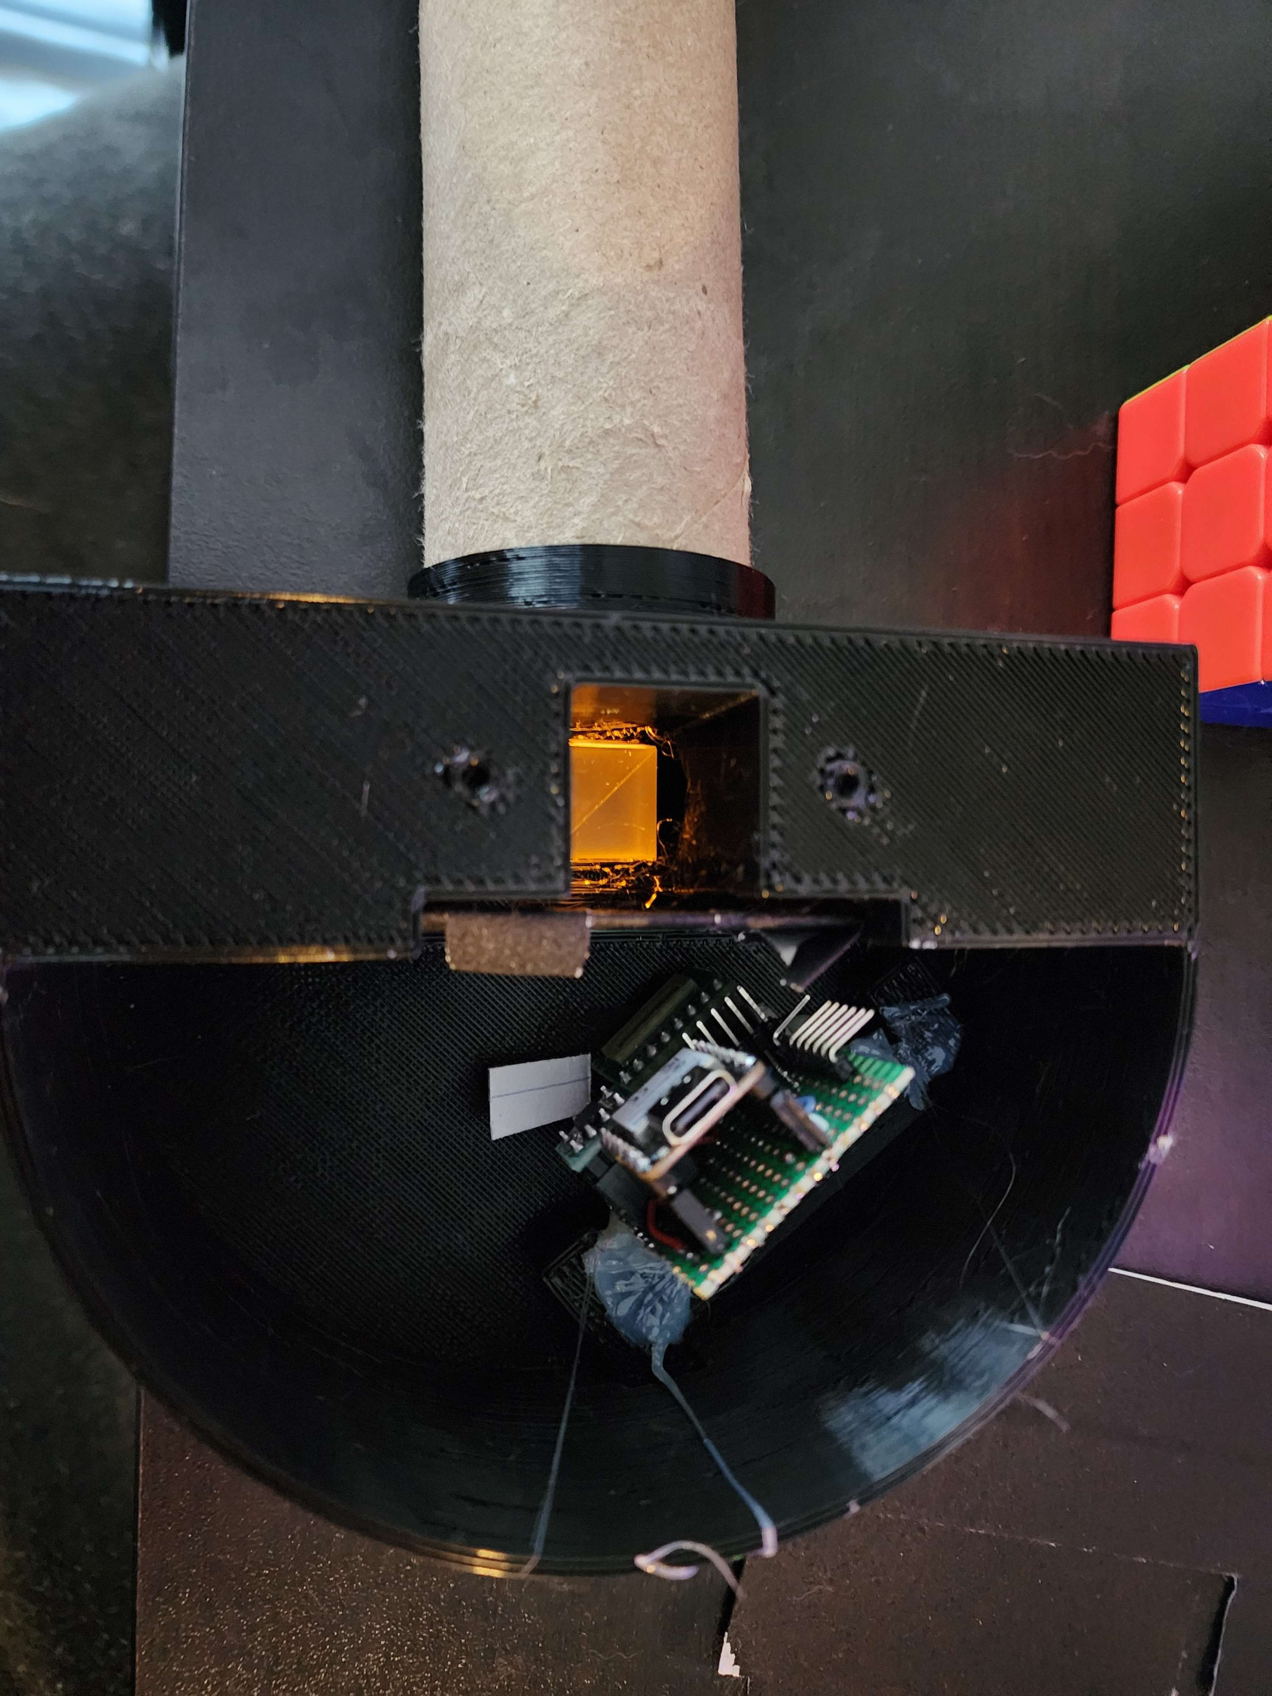

Figure 3. Prototype circuit fixed inside 3D printed body

## Circuit Prototype

We first tested the linear camera on a solderless breadboard to test our custom driver firmware. Once we were certain that we could reliably control the camera we integrated it along with the microcontroller and ADC onto a protoboard. We used header pins and sockets for each component to allow for the removal, testing, and replacement of each component without the need to desolder any components.

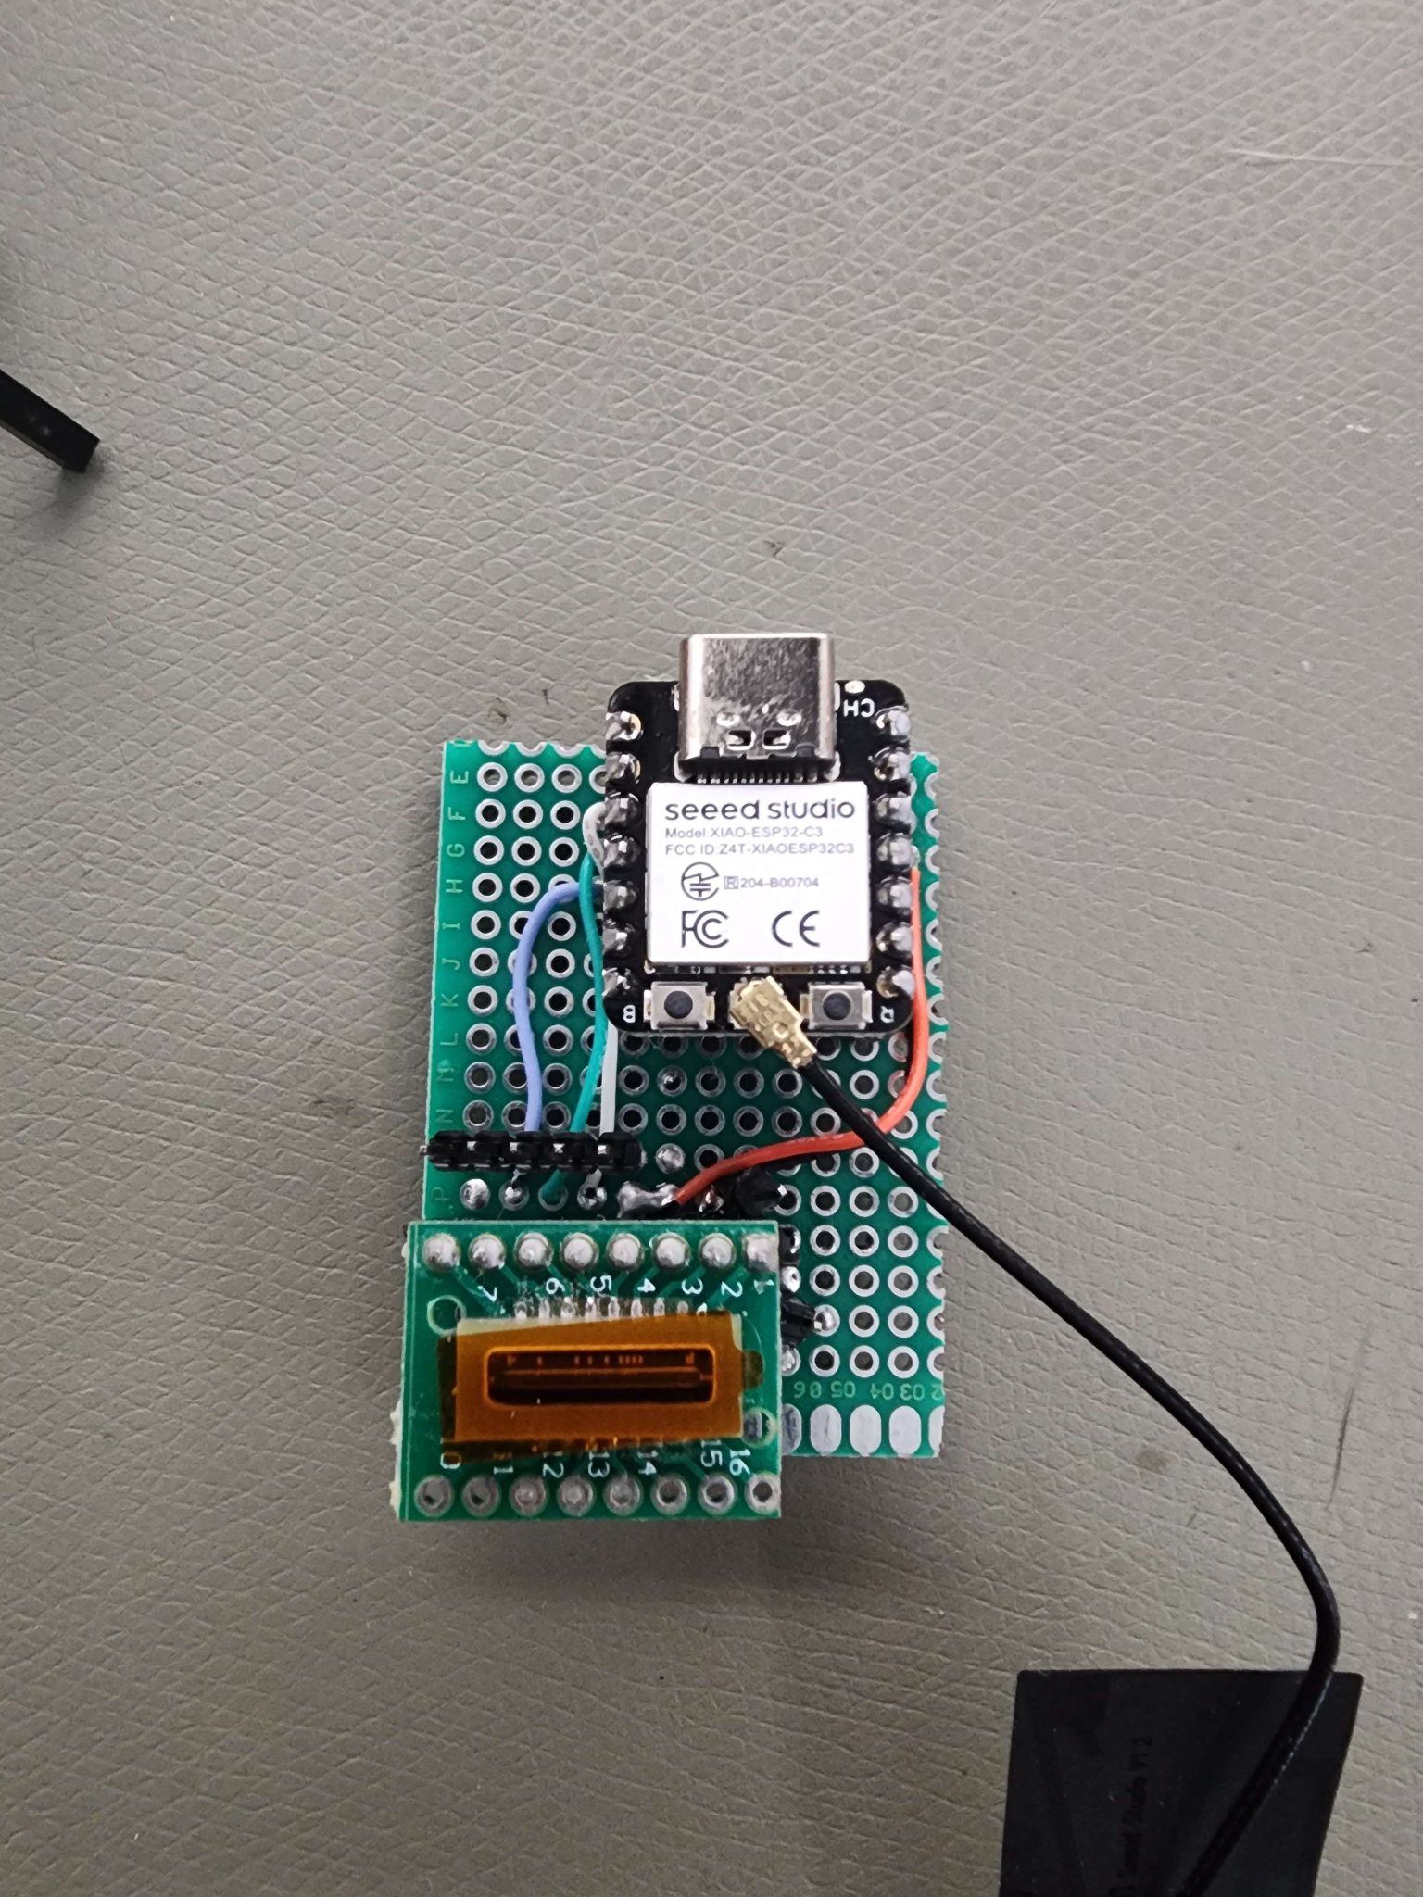

Figure 4. Prototype Circuit board

## Software GUI

For the main control and display program we utilized the IMGUI library to easily create inputs and display the resulting plot on the screen. We created inputs to select the COM port of the attached ESP32-C3, manually calibrate the devices by shifting and scaling the plot, enable the individual filtering steps, and enable and control the nature of the frame integration feature. The GUI itself has three main sections, the first is the initial setup and first plot which contains the inputs for selecting a COM port, displays the unfiltered results, and has the calibration controls. The second section has the controls for selecting the applied filters, and a plot of the resulting filtered signal. The final section has the integration controls where you can enable and disable the feature, set how many frames to average, reset the current average buffer, and view how many frames are currently integrated together.

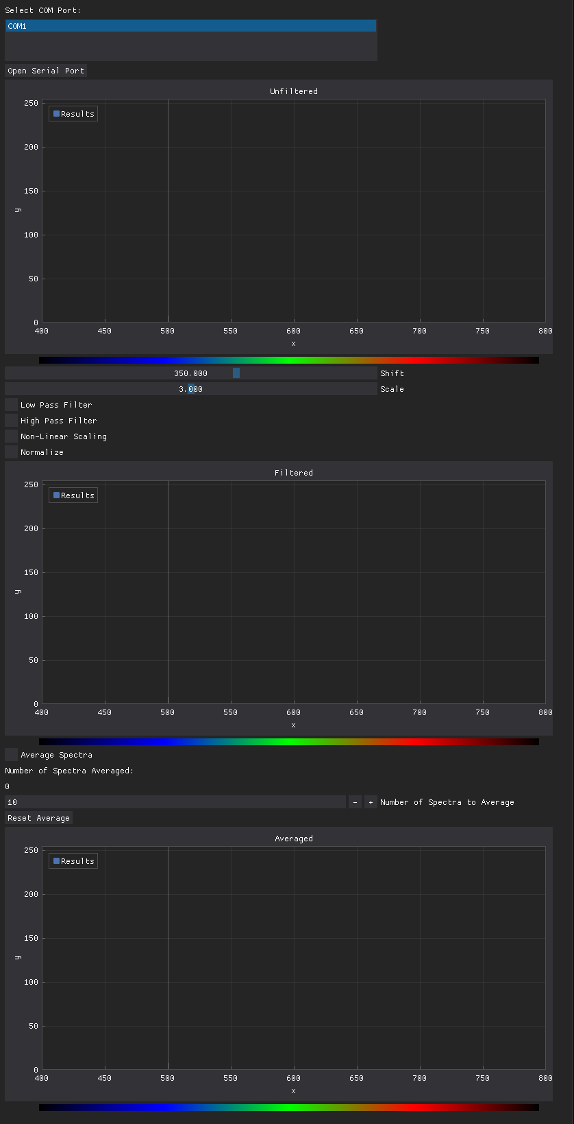

Figure 5. Control program GUI

# Test

## Calibration

To calibrate the device we require two known frequency sources. In this build we utilized the blue 455 nm LED and the deep red 730 nm LED. We start by shifting the plot so that the first displayed peak lines up with the proper location on the wavelength legend, then we scale the plot to line up the second peak, after scaling it might have adjusted the first frequency so the plot needs to be shifted again, we repeat this process of shifting and scaling until the two points are aligned with the correct readings. Then we saved these shift and scale positions as the default so now the device should only need to be checked to ensure it is still in calibration before use.

## LED Array

To test out the linearity, resolution, accuracy, and sensitivity of the device we utilized an array of 9 LED’s to be able to test the entire spectral range of interest. Due to the array being in a square array of 3x3 the 6 LEDS that are not on the center line cause a shift for just those pulses to the left or right of what is expected if the LED array is too close to the detector, using trigonometry we determined that to create pulses that will have a minimal shift from expected we must place the array 900mm from the detector entrance.

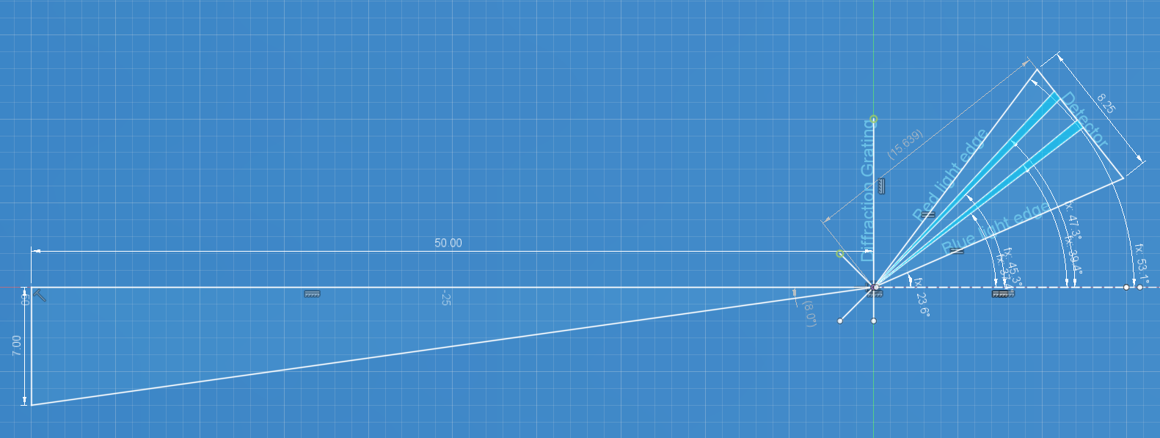

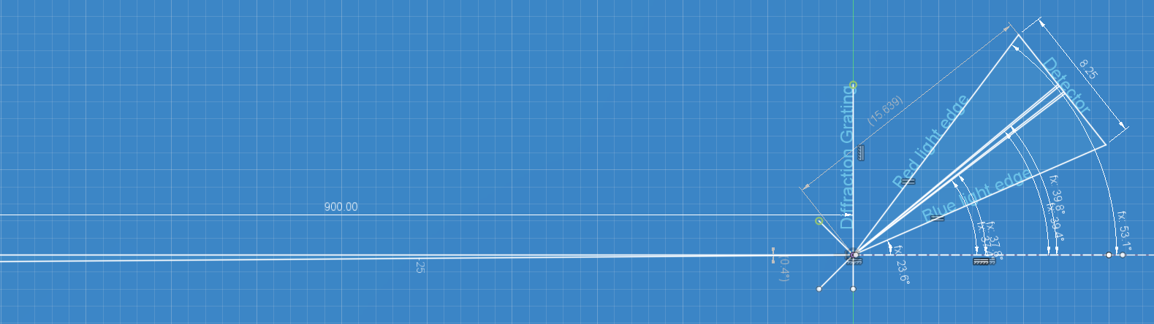

Figure 6. Top LED array too close, Bottom LED array correct distance

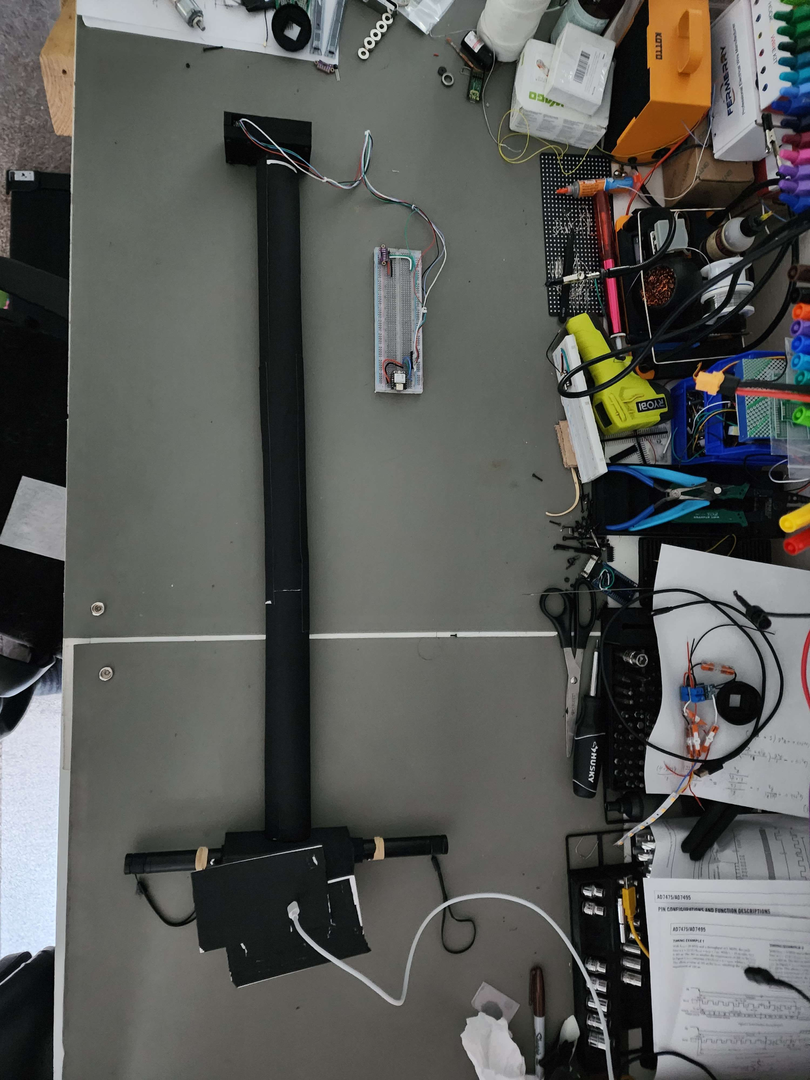

Figure 7. Experimental Setup with LED array, light tube, and spectroscope

For the main 9 LED test we set up the spectroscope with all filters enabled, and the integration feature enabled with 100 samples taken for each frequency.

| 455 nm | 475 nm | 500 nm |
| --- | --- | --- |
| 525 nm | 540 nm | 590 nm |
| 615 nm | 660 nm | 730 nm |

Figure 8. Results from the 9 LED test

From these results we can clearly determine the center frequency of each peak, and it is within $±10$ nm of the expected frequency for each sample, we can also observe the spectral width of each LED. From the manufacturer’s description, both the green 540 nm, and yellow 590 nm LEDs would be more spread out due to the “green gap.” These results indicate that the device could be capable of accurately resolving the frequency of a light input within the parameters needed to determine the existence of a fluorescent marker for life.

# Conclusion

This prototype of a spectroscope for the detection of fluorescent markers of extinct or extant microbial life is a successful proof of concept that a DIY spectroscope based around a cheap diffraction grating and linear CCD camera would be able to resolve the difference in frequency necessary to identify the proper markers of life in a sample of soil. We showed that the device can be calibrated using an external known light source and accurately determine the frequencies of other known sources of light. The device was also capable of resolving signals in all of the target frequency ranges, from at least 455-730 nm. Further work is required to test the device with fluorescent samples, integrate the device with the collection system, and install the system onto the rover, which may also require further iterations on the prototype and redesigns of the body and mounting hardware, but the roadmap for a successfully working device has been completed and now the team can be confident that such a device may be a good solution for this competition.